***Explanation of the Code in convert.js:***

**Purpose:**

The script written in convert.js is used to convert XML data into a JSON format. The XML file, presumably containing hospital information, is read, parsed into JSON, and then saved to a .json file.

**Key Steps in the Code:**

1. **File System and XML Parser Modules**:
   * The script imports the fs module to handle file reading and writing and the xml2js module to parse XML into JSON.

javascript

Copy code

const fs = require('fs');

const xml2js = require('xml2js');

1. **Reading XML File**:
   * The fs.readFile function is used to read the XML file (ushospitals.xml). In case of an error, it throws the error.

javascript

Copy code

fs.readFile('ushospitals.xml', (err, data) => {

if (err) throw err;

1. **Parsing XML to JSON**:
   * The XML data is passed to xml2js's parseString method, which converts the XML into a JavaScript object. Again, errors during parsing are handled with an error check.

javascript

Copy code

parser.parseString(data, (err, result) => {

if (err) throw err;

1. **Saving JSON Output**:
   * The JSON output is then written to a file (hospitalsModel.json) using fs.writeFile. This saves the converted XML data into a readable JSON format. On success, a log message confirms that the file was saved.

javascript

Copy code

fs.writeFile('hospitalsModel.json', JSON.stringify(result, null, 2), (err) => {

if (err) throw err;

console.log('JSON file has been saved.');

**Noteworthy Points:**

* This script provides robust error handling through throw err statements.
* The use of JSON.stringify(result, null, 2) ensures that the resulting JSON is formatted with proper indentation for better readability.

***Explanation of hospitalsModel.json File:***

**Purpose:**

This file represents hospital data converted from XML to JSON format. It contains detailed information about hospitals such as provider IDs, names, addresses, and geographic coordinates.

**Structure:**

* **Row Information**: The data is organized into a series of "row" entries. Each row represents a hospital, with its attributes stored as key-value pairs.
* **Attributes**:
  + _id: A unique identifier for the hospital.
  + provider_id: A unique code for the hospital.
  + hospital_name: The name of the hospital.
  + address, city, state, zip_code, county_name: Contact and location details.
  + hospital_type, hospital_ownership: Information about the type and ownership of the hospital.
  + emergency_services: A boolean indicating whether the hospital provides emergency services.
  + location: Coordinates (latitude and longitude) and a human-readable address.

**Example:**

For instance, the first entry in the JSON is:

json

Copy code

{

"_id": "1",

"provider_id": "010001",

"hospital_name": "SOUTHEAST ALABAMA MEDICAL CENTER",

"address": "1108 ROSS CLARK CIRCLE",

"city": "DOTHAN",

"state": "AL",

"zip_code": "36301",

"county_name": "HOUSTON",

"emergency_services": "true",

"location": {

"latitude": "31.215379379000467",

"longitude": "-85.36146587999968"

}

}

This entry contains all the essential details of "SOUTHEAST ALABAMA MEDICAL CENTER," including its geographical coordinates, which can be useful for mapping purposes.

***MongoDB Compass Screenshot:***

**Overview:**

The uploaded screenshot displays a MongoDB collection (hospitals) in the carefinders database within MongoDB Compass.

**Key Points:**

* **Collection Statistics**: The hospitals collection contains 1 document, with an average document size of 4.06 MB.
* **Indexes**: The collection has 1 index, which helps improve the efficiency of search queries within MongoDB.
* **Storage Size**: The total storage size used by the hospitals collection is 1.13 MB.

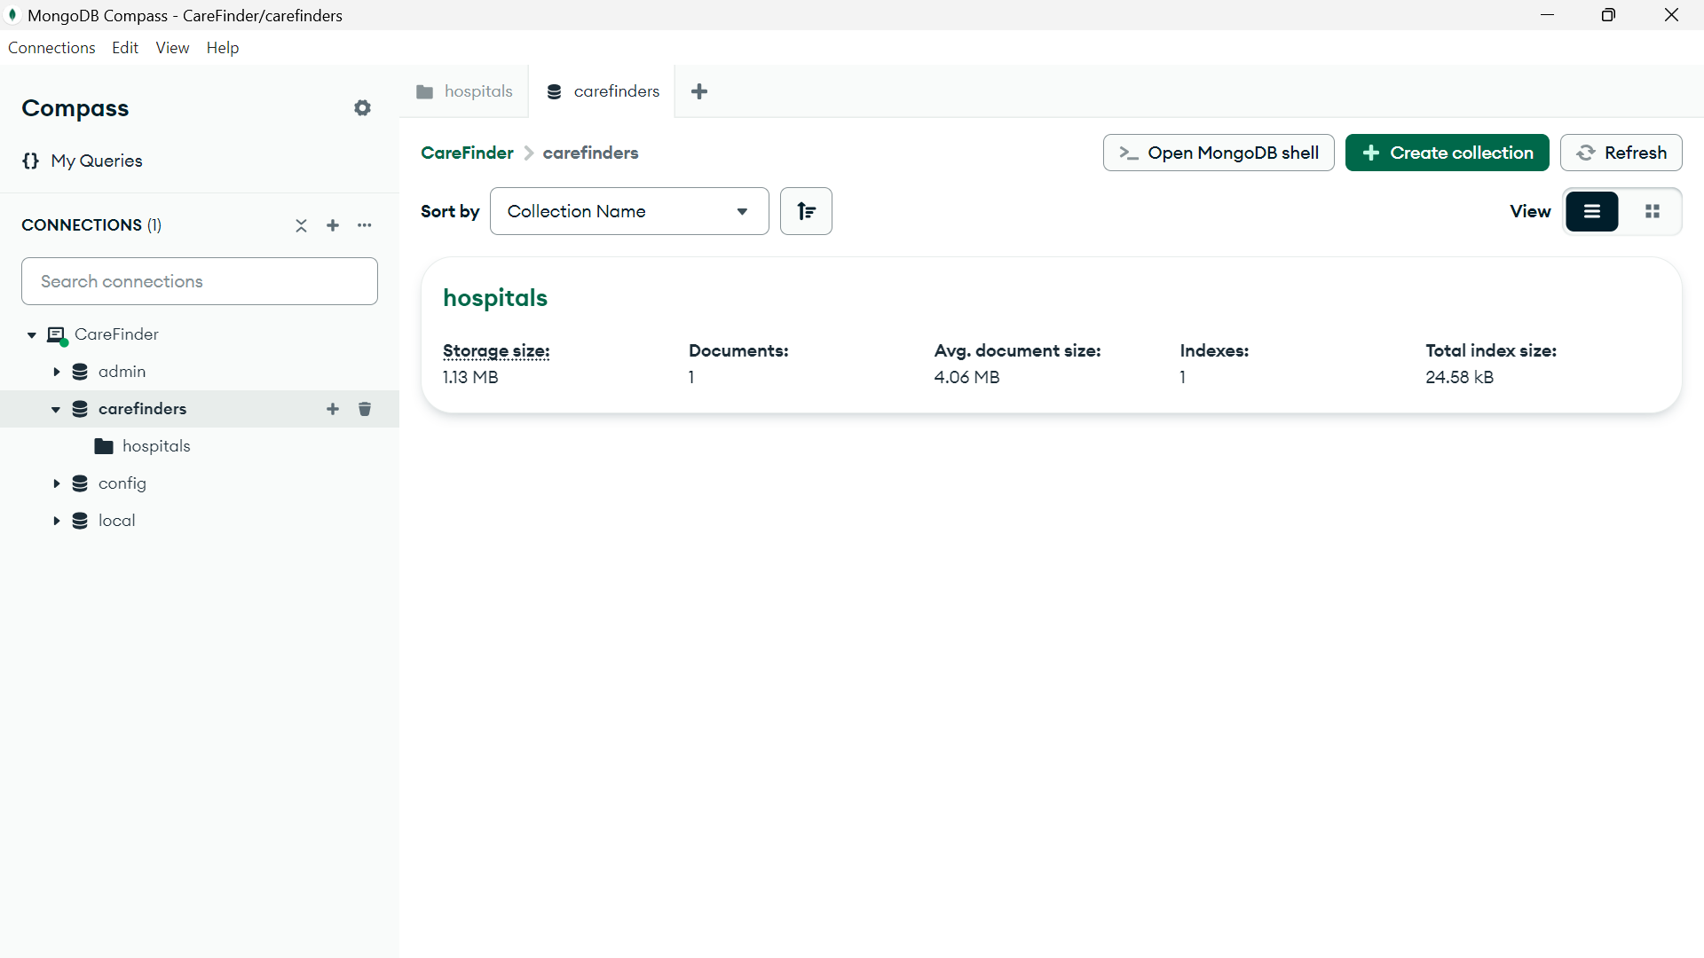

**Summary of Key Highlights:**

1. **Code**:
   * Converts XML data (likely hospital data) into a JSON format.
   * Makes use of asynchronous operations with proper error handling.
   * Ensures readable JSON output by applying formatting options in JSON.stringify.
2. **JSON File**:
   * Contains structured hospital data with various fields such as hospital name, location, and type.
   * Useful for storing and querying hospital data in applications such as hospital locators or healthcare management systems.
3. **MongoDB Compass**:
   * The hospitals collection in MongoDB Compass provides information about hospital documents.
   * MongoDB indexes ensure faster querying, and the collection's storage details are displayed efficiently.